2.67: The total distance you cover is 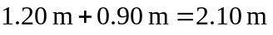and the time available is 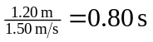. Solving Eq. (2.12) for a_{x},


